August 31, 2022

Dear Parents/Guardians,

On behalf of the Westwind Staff, we hope you have had a relaxing summer and have enjoyed time with your family and friends. We are excited to join the Westwind School community and we are looking forward to a wonderful year getting to know you and your children!

Here is some important information for the first week of school:

FIRST DAY: Tuesday, September 6:

8:45 – 9:45 am
Last year’s Div. 10 – 16 Attend*
New Primary Students (Going into Gr. 1-3) Attend**

9:00 – 9:45 am
Kindergarten Students Attend

12:30 – 1:30 pm
Last year’s Div. 1 - 9 Attend*
New Intermediate Students (Going into Gr. 4-7) Attend**

*See “First Week Room Assignments” sheet for more info!
**New students to Westwind, please come to the office on the first day for temporary placement in a classroom. Primary students, arrive at 8:35 a.m.; intermediate students, arrive at 12:20 p.m. We have prepared a map and an assignment for you! Parents of new students, please remember the door you’ve dropped your child off at on the first day, as this will be their pick-up/drop-off spot for the week!

Students will be placed with their last year’s teacher for the first week of school, or with another staff member if their teacher is no longer at the school. Grade 1 students will be assigned to another staff member while the Kindergarten teachers follow the Gradual Entry schedule for our new K students.

Regular school hours will begin on Wednesday, September 7 for students in Grades 1-7: 8:45 a.m. to 2:45 p.m. Kindergarten students will follow their own gradual entry schedule for the first 2 weeks.

Please refer to the “First Week Room Assignments” sheet (attached) for pick up and drop off locations. Your child’s teacher will greet you near the designated entrance at the start of the school day and bring them outside to meet you at the end of the school day.

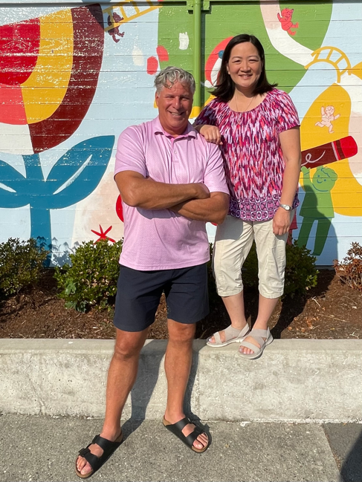
Exciting new look coming for our hallways! We are so pleased that our hallway floors are being redone this summer! However, due to supply issues, the work is taking longer than expected to complete, so we will need to limit the traffic inside the building for the first week or so. After the renovation is complete, we will be able to welcome families into the school more easily. Thank you for your understanding and patience as this work is completed.

Parents, join us for “Welcome Back” coffee and treats at the basketball court behind the school while you wait for your children! Come and meet the new admin team, connect with other parents, share summer stories and get our year off to a great start! Hope to see you there!

Thank you so much for your warm wishes of welcome! We look forward to meeting you in person and getting to know you over the coming year. Our doors are always open – please come and say hello at any time and do not hesitate to contact us for any reason whatsoever.

Warm regards,

Mr. Bill Juhasz Mrs. Susan Tse
Principal Vice-Principal

